Biobank & Biospecimen Management System
Course: Fundamentals of Databases
Team Leader: [malak ahmed Mohamed ]
Id:241002087

1. Problem Statement, Scope & Business Rules

1.1 Problem Statement
A biobank collects, stores, and distributes human biospecimens — blood, saliva, tissue, and derivatives — for research use. Manually tracking specimens across spreadsheets or paper logs makes it difficult to answer basic operational questions: Is a donor's consent still valid? Where, physically, is a given aliquot stored, and at what temperature? How much of a sample remains after repeated testing? Which researcher requested which test, and what is its status? This project designs and implements a relational database that answers these questions reliably and enforces the rules that keep the data trustworthy.

1.2 Scope
In scope: donor enrollment and informed consent, sample collection events, sample aliquoting and cold-chain storage tracking, researcher-submitted test requests, and recording of sample usage against test requests, always validated against active donor consent.
Out of scope: billing and invoicing, physical shipping/courier logistics, and full clinical medical records (only anonymized donor identifiers are modeled).

1.3 Assumptions
- Each donor is anonymized by a donor_code; no direct personal names are stored in the database.
- A donor may sign multiple consent forms over time (renewals); only the most recent status per form matters operationally.
- A sample collected during one CollectionEvent may be split into multiple aliquots for separate storage or use.
- A single aliquot can be partially consumed across multiple test requests over time.

1.4 Key Business Rules
- A sample's aliquot cannot be used (recorded in SampleUsage) unless the owning donor currently has an Active consent.
- All recorded volumes (Sample, Aliquot, SampleUsage) must be strictly positive.
- A consent form's expiry_date, when present, must be later than its date_signed.
- An aliquot's status is derived automatically from its accumulated usage, not set manually.

2. Conceptual Design
The system is modeled around ten entities: nine core entities plus one associative entity (SampleUsage) that resolves a many-to-many relationship. Primary keys are underlined in the ER diagram (Section 3) and marked “(PK)” below; foreign keys are marked “(FK)”.
2.1 Donor
Represents an anonymized biospecimen donor. Identified only by a generated donor_code, never a real name, to protect privacy.
Attribute | Type | Notes
donor_id (PK) | SERIAL | Surrogate primary key
donor_code | VARCHAR(20) | Unique anonymized identifier
date_of_birth | DATE | Used to compute age when needed (derived, not stored)
sex | VARCHAR(10) | Restricted to a fixed set of values
contact_email | VARCHAR(120) | Optional
enrollment_date | DATE | Defaults to the date of enrollment

2.2 Researcher
A staff member who conducts collection events or submits test requests.
Attribute | Type | Notes
researcher_id (PK) | SERIAL | Surrogate primary key
full_name | VARCHAR(100) | —
department | VARCHAR(100) | —
email | VARCHAR(120) | Unique, used as a natural contact key

2.3 ConsentForm
A weak entity: a consent record only has meaning in the context of its owning Donor. Modeled as weak because it cannot be uniquely identified without donor_id.
Attribute | Type | Notes
consent_id (PK) | SERIAL | Surrogate key, still unique on its own
donor_id (FK) | INT | References Donor; identifying relationship
consent_type | VARCHAR(50) | Research / Commercial / Broad / Restricted
date_signed | DATE | —
expiry_date | DATE | Nullable; must be after date_signed when present
status | VARCHAR(20) | Active / Withdrawn / Expired

2.4 CollectionEvent
A single visit/session in which one or more samples are collected from a donor.
Attribute | Type | Notes
event_id (PK) | SERIAL | Surrogate primary key
donor_id (FK) | INT | References Donor
collected_by (FK) | INT | References Researcher
event_date | DATE | —
location | VARCHAR(100) | —

2.5 SampleType
Lookup table of specimen categories (blood, saliva, tissue, etc.), factored out to avoid repeating storage requirements on every sample row (3NF).
Attribute | Type | Notes
sample_type_id (PK) | SERIAL | Surrogate primary key
type_name | VARCHAR(50) | Unique
storage_requirements | VARCHAR(100) | e.g. ‘-80C freezer’

2.6 Sample
A physical specimen collected during a CollectionEvent, of a given SampleType, belonging to a Donor.
Attribute | Type | Notes
sample_id (PK) | SERIAL | Surrogate primary key
donor_id (FK) | INT | References Donor
sample_type_id (FK) | INT | References SampleType
event_id (FK) | INT | References CollectionEvent
collection_date | DATE | —
volume_ml | DECIMAL(6,2) | Must be > 0
status | VARCHAR(20) | Available / Depleted / Quarantined / Disposed

2.7 StorageLocation
A physical freezer/shelf/rack/position used to store aliquots.
Attribute | Type | Notes
location_id (PK) | SERIAL | Surrogate primary key
freezer_id | VARCHAR(20) | —
shelf, rack, position | VARCHAR(10) | Together with freezer_id, unique
temperature_c | DECIMAL(5,1) | —

2.8 Aliquot
A sub-volume split from a Sample, stored at a specific StorageLocation, and consumable across multiple test requests.
Attribute | Type | Notes
aliquot_id (PK) | SERIAL | Surrogate primary key
sample_id (FK) | INT | References Sample
location_id (FK) | INT | References StorageLocation
volume_ml | DECIMAL(6,2) | Must be > 0
creation_date | DATE | —
status | VARCHAR(20) | Stored / InUse / Depleted / Discarded — set automatically by trigger

2.9 TestRequest
A researcher's request to run a specific test on a sample.
Attribute | Type | Notes
request_id (PK) | SERIAL | Surrogate primary key
sample_id (FK) | INT | References Sample
researcher_id (FK) | INT | References Researcher
test_type | VARCHAR(80) | —
request_date | DATE | —
status | VARCHAR(20) | Pending / Approved / Completed / Rejected

2.10 SampleUsage (associative entity)
Resolves the many-to-many relationship between Aliquot and TestRequest: one aliquot can serve multiple requests, and one request can draw on multiple aliquots. Each row records exactly how much volume was consumed, when, and why.
Attribute | Type | Notes
usage_id (PK) | SERIAL | Surrogate primary key
aliquot_id (FK) | INT | References Aliquot
request_id (FK) | INT | References TestRequest
usage_date | DATE | —
quantity_used_ml | DECIMAL(6,2) | Must be > 0
purpose | VARCHAR(150) | Free-text note

3. ER Diagram
The diagram below uses Chen notation: rectangles for entities, diamonds for relationships, and ellipses for attributes. ConsentForm is drawn as a double-bordered rectangle (weak entity) connected through the double-diamond identifying relationship ‘Signs’. Donor_Name is a composite attribute (split into First_Name / Last_Name); Age is a dashed, derived attribute computed from date_of_birth; Contact_Phone is a double-bordered, multivalued attribute. Every line is labeled with (min,max) participation/cardinality.
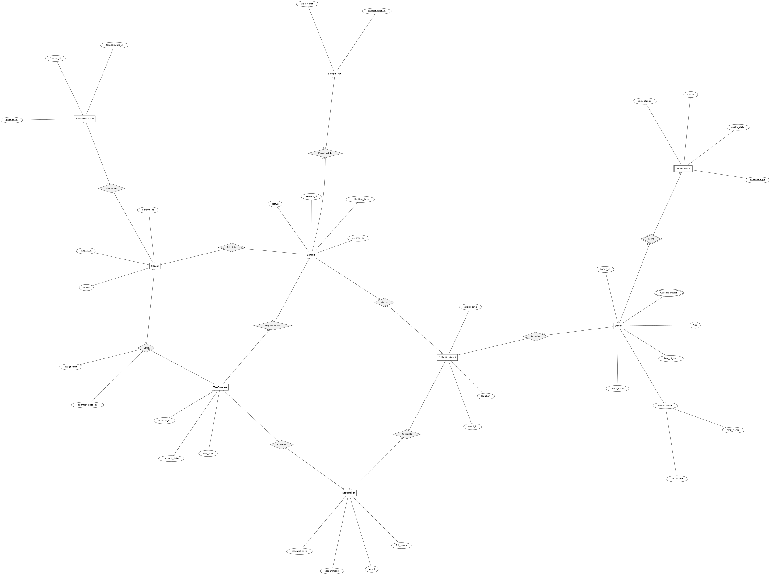

3.1 Relationships, Cardinality & Participation
Relationship | Between | Cardinality | Participation
Signs (identifying) | Donor → ConsentForm | 1 : N | Donor total; ConsentForm total (weak entity)
Provides | Donor → CollectionEvent | 1 : N | Donor total; CollectionEvent total
Conducts | Researcher → CollectionEvent | 1 : N | Researcher partial; CollectionEvent total
Yields | CollectionEvent → Sample | 1 : N | CollectionEvent total; Sample total
Classified As | SampleType → Sample | 1 : N | SampleType partial; Sample total
Split Into | Sample → Aliquot | 1 : N | Sample total; Aliquot total
Stored At | StorageLocation → Aliquot | 1 : N | StorageLocation partial; Aliquot total
Requested For | Sample → TestRequest | 1 : N | Sample partial; TestRequest total
Submits | Researcher → TestRequest | 1 : N | Researcher partial; TestRequest total
Uses | Aliquot ↔ TestRequest | M : N | Both partial — resolved via SampleUsage
4. Relational Schema
Every 1:N ER relationship becomes a foreign key placed on the ‘many’ side. The single M:N relationship (Aliquot ↔ TestRequest) becomes its own table, SampleUsage, carrying both foreign keys plus its own attributes.
Table | Primary Key | Foreign Keys | Other Constraints
Donor | donor_id | — | donor_code UNIQUE; sex CHECK IN(...)
Researcher | researcher_id | — | email UNIQUE
ConsentForm | consent_id | donor_id → Donor | consent_type / status CHECK IN(...); expiry_date > date_signed
CollectionEvent | event_id | donor_id → Donor; collected_by → Researcher | —
SampleType | sample_type_id | — | type_name UNIQUE
Sample | sample_id | donor_id → Donor; sample_type_id → SampleType; event_id → CollectionEvent | volume_ml > 0; status CHECK IN(...)
StorageLocation | location_id | — | UNIQUE(freezer_id, shelf, rack, position)
Aliquot | aliquot_id | sample_id → Sample; location_id → StorageLocation | volume_ml > 0; status CHECK IN(...)
TestRequest | request_id | sample_id → Sample; researcher_id → Researcher | status CHECK IN(...)
SampleUsage | usage_id | aliquot_id → Aliquot; request_id → TestRequest | quantity_used_ml > 0; UNIQUE(aliquot_id, request_id, usage_date)

5. Normalization

5.1 First Normal Form (1NF)
Every attribute holds a single atomic value. A Sample never stores a list of aliquot IDs in one field — Aliquot is a separate table, one row per physical aliquot.

5.2 Second Normal Form (2NF)
Every table uses a single-column surrogate primary key (e.g. sample_id, aliquot_id), so no non-key attribute can depend on only part of a composite key — partial dependency is structurally impossible here.

5.3 Third Normal Form (3NF)
Transitive dependencies were removed by factoring out lookup data. storage_requirements depends only on SampleType, not on any individual Sample, so SampleType is its own table instead of being repeated on every Sample row. Likewise StorageLocation details (freezer_id, temperature_c) are not duplicated on every Aliquot.
6. Implementation: DDL & DML

6.1 DDL — create_tables.sql
Table creation combines primary keys, foreign keys with referential actions, and CHECK constraints so that data-integrity rules live inside the schema itself rather than in application code. Example (ConsentForm):
CREATE TABLE ConsentForm (
consent_id SERIAL PRIMARY KEY,
donor_id INT NOT NULL REFERENCES Donor(donor_id) ON DELETE CASCADE,
consent_type VARCHAR(50) NOT NULL CHECK (consent_type IN
('Research','Commercial','Broad','Restricted')),
date_signed DATE NOT NULL,
expiry_date DATE,
status VARCHAR(20) NOT NULL DEFAULT 'Active'
CHECK (status IN ('Active','Withdrawn','Expired')),
CONSTRAINT chk_consent_dates
CHECK (expiry_date IS NULL OR expiry_date > date_signed)
);
The full DDL for all ten tables, including indexes on frequently-joined foreign key columns, is in /sql/create_tables.sql.

6.2 DML — queries.sql
The query file demonstrates every required operation type:
- Retrieval: simple WHERE filters, e.g. donors enrolled in a given year.
- Joins: multi-table joins, e.g. aliquots with donor, type, and storage location.
- Aggregation: GROUP BY with COUNT/AVG/SUM, and HAVING, e.g. researchers with more than one request.
- Subqueries: both simple (IN) and correlated subqueries, e.g. aliquots whose usage already exceeds 50% of their original volume.
- INSERT: registering a new donor and their first consent form.
- UPDATE: marking a sample Depleted once all its aliquots are consumed; withdrawing a consent form.
- DELETE: removing rejected test requests that were never used.
-- Correlated subquery example
SELECT a.aliquot_id, a.volume_ml
FROM Aliquot a
WHERE (
SELECT COALESCE(SUM(su.quantity_used_ml), 0)
FROM SampleUsage su
WHERE su.aliquot_id = a.aliquot_id
) > 0.5 * a.volume_ml;

6.3 Views — views.sql
View | Purpose
vw_sample_inventory | One row per sample with donor, type, live aliquot count, and remaining volume — lets lab staff check stock without writing joins.
vw_researcher_activity | Per-researcher request counts, completion rate, and total volume consumed — used for reporting.

7. Test Data
load_data.sql populates every main table with 10 representative rows (6 rows for the small SampleType lookup table, which is logically sufficient). Row counts were confirmed by direct execution (see Section 9 for the full test log):
Table | Rows Loaded
Donor | 10
Researcher | 10
ConsentForm | 10
CollectionEvent | 10
SampleType | 6
Sample | 10
StorageLocation | 10
Aliquot | 10
TestRequest | 10
SampleUsage | 10
Sample rows (first 5 of the Donor table):
donor_id | donor_code | sex | enrollment_date
1 | DNR-0001 | Female | 2022-01-10
2 | DNR-0002 | Male | 2022-01-12
3 | DNR-0003 | Female | 2022-02-01
4 | DNR-0004 | Male | 2022-02-15
5 | DNR-0005 | Other | 2022-03-03

8. Design Choices & Implementation Rationale

8.1 Why these entities?
Each entity corresponds to a distinct real-world object the lab needs to track independently: a Donor is not the same as their Sample, and a Sample is not the same as any one of its Aliquots — each has its own lifecycle, status, and attributes. Splitting SampleType and StorageLocation into lookup tables avoids duplicating storage rules on every row.

8.2 Why these relationships?
Most relationships are 1:N because that reflects how the domain actually works — one donor gives many samples over time, one sample is split into many aliquots. The one true M:N relationship, Aliquot ↔ TestRequest, exists because a single vial can serve multiple test requests and a single request can draw on multiple vials; that is exactly the case that requires an associative table.

8.3 Why these constraints?
CHECK constraints on volume columns (> 0) prevent physically meaningless data from ever being stored. The consent-date CHECK prevents an expiry date from silently predating its signing date. Foreign keys with ON DELETE CASCADE keep the database consistent when a donor record is removed, propagating the deletion sensibly rather than leaving orphaned rows.

8.4 Normalization decisions
See Section 5. The key decision was factoring SampleType and StorageLocation into standalone lookup tables rather than embedding their attributes directly on Sample/Aliquot — this removes transitive dependencies and means a change to a sample type's storage requirement only touches one row.

9. Triggers & Stored Procedure

9.1 trg_check_consent_before_usage
Fires BEFORE INSERT on SampleUsage. It looks up the donor behind the aliquot being used and checks whether that donor currently has an Active consent record. If not, it raises an exception and the insert (and its transaction) is rejected. This is needed because consent can be withdrawn at any time after samples have already been collected — the database must not allow further use of that donor's material once consent is gone, and this cannot be expressed with a simple CHECK constraint because it requires looking across three tables (SampleUsage → Aliquot → Sample → ConsentForm).
CREATE OR REPLACE FUNCTION fn_check_consent_before_usage()
RETURNS TRIGGER AS $$
DECLARE
v_donor_id INT;
v_consent_ok BOOLEAN;
BEGIN
SELECT s.donor_id INTO v_donor_id
FROM Aliquot a JOIN Sample s ON a.sample_id = s.sample_id
WHERE a.aliquot_id = NEW.aliquot_id;

SELECT EXISTS (
SELECT 1 FROM ConsentForm c
WHERE c.donor_id = v_donor_id AND c.status = 'Active'
) INTO v_consent_ok;

IF NOT v_consent_ok THEN
RAISE EXCEPTION 'Cannot record sample usage: donor % has no active consent', v_donor_id;
END IF;
RETURN NEW;
END; $$ LANGUAGE plpgsql;

9.2 trg_update_aliquot_status
Fires AFTER INSERT on SampleUsage. It sums all usage recorded against the affected aliquot and automatically updates that aliquot's status — to InUse once any volume has been consumed, or to Depleted once the accumulated usage reaches its original volume. This means aliquot status is always derived from actual data rather than manually maintained, so it can never drift out of sync with reality.

9.3 sp_record_sample_usage — stored function
Wraps the SampleUsage INSERT and returns the aliquot's remaining volume in a single call, giving the lab application one safe entry point instead of a raw multi-step INSERT plus a follow-up SELECT.
SELECT sp_record_sample_usage(8, 8, 2.5, 'Additional tumor marker replicate');
-- returns the aliquot's remaining volume after the usage is recorded

10. Testing
Testing was carried out by executing the actual schema, seed data, views, and triggers against a live database and capturing the real output (rather than describing expected behaviour only). For portability during development this was run on SQLite with an equivalent adapted schema (identical constraints and trigger logic, different trigger syntax); the production target remains PostgreSQL as specified in create_tables.sql. The full console output is reproduced below.

10.1 Schema load and row counts
Schema created successfully: 10 tables, 2 triggers, 2 views.

Row counts after load:
Donor 10 rows Researcher 10 rows
ConsentForm 10 rows CollectionEvent 10 rows
SampleType 6 rows Sample 10 rows
StorageLocation 10 rows Aliquot 10 rows
TestRequest 10 rows SampleUsage 10 rows

10.2 Query & view execution
-- Join: aliquots with donor, type, storage location
aliquot_id donor_code type freezer status
1 DNR-0001 Whole Blood FRZ-1 InUse
2 DNR-0001 Whole Blood FRZ-1 InUse
3 DNR-0002 Plasma FRZ-2 InUse
4 DNR-0003 Saliva FRZ-2 InUse
5 DNR-0004 Whole Blood FRZ-1 InUse

-- View: vw_researcher_activity
researcher total_req completed volume_used_ml
Dr. Amina Youssef 3 2 9
Dr. Karim Fathy 2 2 2
Dr. Laila Hassan 2 0 1.5

10.3 Business-rule and constraint tests
# | Test Case | Expected | Actual Result
1 | Withdraw donor #1's consent, then INSERT SampleUsage for their aliquot | Rejected | REJECTED — “Cannot record sample usage: donor has no active consent”
2 | INSERT Aliquot with volume_ml = -5 | Rejected | REJECTED — CHECK constraint failed: volume_ml > 0
3 | Fully consume aliquot #6 via a second SampleUsage row | Status → Depleted | Aliquot #6 status changed InUse → Depleted automatically
4 | INSERT ConsentForm with expiry_date before date_signed | Rejected | REJECTED — CHECK constraint failed: chk_consent_dates
All four test cases produced the expected result, confirming that the CHECK constraints and both triggers are enforced by the database itself, not merely assumed.

11. Limitations & Conclusion

11.1 Limitations
- No audit trail of who changed a record and when.
- Freezer/rack storage capacity is not modeled or enforced — the schema does not prevent overbooking a physical location.
- No automated alerting when a consent form is approaching its expiry date.

11.2 Conclusion
The project delivers a normalized (3NF), fully constrained relational schema for biobank operations, with referential integrity, CHECK-based domain rules, two reporting views, and two triggers plus a stored function that together make the database self-enforcing rather than relying on application code to maintain consistency. Testing against real data confirmed every constraint and trigger behaves as designed.

11.3 Next Step (Bonus)
A connected front-end application (Python/Flask or Node) is planned for the bonus deliverable, providing live search/filter over vw_sample_inventory and validated CRUD operations that route sample-usage writes through sp_record_sample_usage.

12. Optional Connected User Interface (Bonus)
An optional Flask-based web interface was developed to provide a user-friendly way to interact with the Biobank and Biospecimen Management System. The application connects to the project database and uses database records as its source of truth rather than relying on static or hard-coded data.
12.1 Database Connectivity
The Flask application uses a dedicated database access layer (db.py) to execute SQL queries and database operations. The application supports connection to the PostgreSQL database through the DATABASE_URL environment variable. A local SQLite database is also supported for demonstration and development purposes.
12.2 Data Viewing and Searching
The interface provides a dashboard for viewing the sample inventory. Users can view donor codes, sample types, collection dates, sample statuses, aliquot counts, and total aliquot volume. Search and filtering functions allow users to find samples using donor codes or sample types and to filter samples according to their current status.
12.3 CRUD Operations
The interface supports Create, Read, Update, and Delete operations for the main application workflows. Donor records can be created, edited, viewed, and deleted. Similar operations are provided for samples and test requests. All modifications are performed through SQL operations on the database.
12.4 Input Validation and Error Handling
The application validates user input before database operations are performed. Required fields are checked, permitted values are restricted to the defined database domains, and invalid values such as non-positive sample volumes are rejected. Database errors and constraint violations are captured and displayed to the user.
12.5 Integration with the Database
The user interface is directly integrated with the implemented relational database. This ensures that records displayed in the application correspond to actual database records and that create, update, and delete operations modify the underlying database rather than temporary application data.
12.6 Bonus Criteria Coverage
The application addresses the five bonus assessment areas:
- Database connectivity and setup: The Flask application connects to the project database through the database access layer.
- Data viewing and searching: The dashboard and list pages provide record viewing, searching, and filtering.
- Create/update/delete operations: Forms allow validated CRUD operations on donors, samples, and test requests.
- Usability and input validation: The interface validates required fields and allowed values and reports database errors.
- Integration quality and demonstration: The application is integrated with the submitted database and can be demonstrated as an additional user-facing component.
12.7 Demonstration
The Flask interface can be demonstrated during the project presentation by showing the dashboard, searching and filtering sample records, creating or editing a donor record, and demonstrating input validation and database error handling. This provides a practical user-facing layer over the PostgreSQL database implementation.

